Experiment No: 01
Experiment Name: Convert RGB Image to Grayscale Image and Show Image Matrix
Objectives:
- To understand RGB color images and grayscale images.
- To learn image processing basics using Python.
- To convert an RGB image into a grayscale image.
- To display the pixel matrix of an image.
- To gain practical knowledge of image manipulation using Python libraries.
Theory:
A digital color image is usually represented using the RGB color model, where each pixel contains three color components:
R = Red
G = Green
B = Blue
A grayscale image contains only intensity information instead of color. Each pixel has a single value representing brightness, ranging from:
0 = Black
255 = White
The grayscale value is commonly calculated using the weighted average formula:
Gray=0.299R+0.587G+0.114B
This formula gives more importance to green because the human eye is more sensitive to green light.
Code:
from PIL import Image
import numpy as np
import matplotlib.pyplot as plt

image = Image.open('sm_pic.jpg').convert('RGB')
gray_image = image.convert('L')
gray_matrix = np.array(gray_image)
plt.figure(figsize=(10, 5))
plt.subplot(1, 2, 1)
plt.title('Original RGB Image')
plt.imshow(image)
plt.subplot(1, 2, 2)
plt.title('Grayscale Image')
plt.imshow(gray_image, cmap='gray')
plt.show()
print("Grayscale Image Matrix:")
print(gray_matrix)
Output:
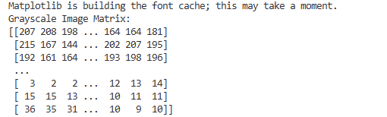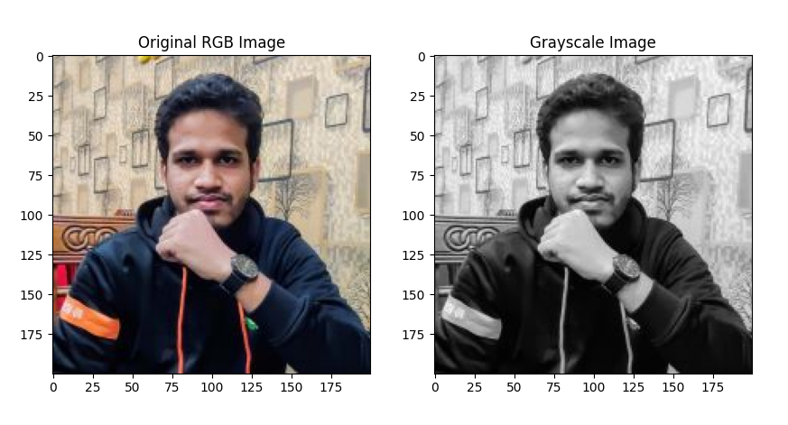

Result and Discussion: In this experiment, an RGB image was converted into a grayscale image using Python image processing libraries. The grayscale conversion reduced the image from three color channels to a single intensity channel, making the image simpler for analysis and processing.
The pixel matrices of both RGB and grayscale images were displayed successfully. This experiment demonstrates the fundamental concept of image representation and preprocessing in digital image processing systems.
The lab helps build a foundation for advanced image processing tasks such as edge detection, object recognition, and computer vision applications.

